|  |  |
| --- | --- |
| C:\Users\Mechanical\Desktop\My Documents\dsi-logo.png | **DAYANANDA SAGAR COLLEGE OF ENGINEERING**  **DEPARTMENT OF MECHANICAL ENGINEERING**  **(Accredited by NBA)**  Accredited by National Assessment & Accreditation Council (NAAC) with ’A’ Grade  *(AICTE Approved, an Autonomous Institute Affiliated to VTU, Belagavi)*  Shavige Malleshwara Hills, Kumaraswamy Layout, Bengaluru-560078 |

**A Mini Project Report on**

**“Modelling of a Gas Turbine Engine”**

*Submitted in partial fulfilment for the award of degree of*

**BACHELOR OF ENGINEERING**

**IN**

**MECHANICAL ENGINEERING**

*Submitted by*

|  |  |
| --- | --- |
| **1DS17ME008** | **ADITYA KAMATH** |
| **1DS17ME027** | **BHARGHAVA RAJU R** |
| **1DS17ME047** | **JATIN S** |
| **1DS17ME120** | **SHREYAS N** |

*Under the guidance of*

**Prof. Ravi Kumar S.R Prof. Mohan Das A.N**

Assistant Professor Assistant Professor

Department of Mechanical Engineering, Department of Mechanical Engineering,

Dayananda Sagar College of Engineering Dayananda Sagar College of Engineering

S M Hills, Kumara Swamy Layout, S M Hills, Kumara Swamy Layout,

Bengaluru-560078 2019-20 Bengaluru-560078 2019-20

|  |  |
| --- | --- |
| C:\Users\Mechanical\Desktop\My Documents\dsi-logo.png | **DAYANANDA SAGAR COLLEGE OF ENGINEERING**  **DEPARTMENT OF MECHANICAL ENGINEERING**  **(Accredited by NBA)**  Accredited by National Assessment & Accreditation Council (NAAC) with ’A’ Grade  *(AICTE Approved, an Autonomous Institute Affiliated to VTU, Belagavi)*  Shavige Malleshwara Hills, Kumaraswamy Layout, Bengaluru-560078 |

**Certificate**

Certified that the project report entitled **‘Modelling of a gas turbine engine’** is a bonafide work carried out by **Mr. Aditya Kamath** bearing USN: **1DS17ME008**, **Mr. Bharghava R Raju** bearing USN**: 1DS17ME027**, **Mr. Jatin S** bearing USN: **1DS17ME047**, **Mr. Shreyas Nagaraj** bearing USN: **1DS17ME120** under the guidance of **Mr. Ravi Kumar S.R**, Assistant Professor, Department of Mechanical, Dayananda Sagar College of Engineering, Bengaluru and **Mr. Mohan Das A.N** Assistant Professor, Department of Mechanical, Dayananda Sagar College of Engineering, Bengaluru in partial fulfilment for the award of Bachelor of Engineering in Mechanical Engineering of the Visvesvaraya Technological University, Belagavi.

Mr. Mohan Das A.N

Assistant Professor

Department of Mechanical Engineering

Dayananda Sagar College of Engineering.

Bengaluru

Mr. Ravi Kumar S.R

Assistant Professor

Department of Mechanical Engineering

Dayananda Sagar College of Engineering.

Bengaluru

Dr. C. P. S. Prakash

Principal

Dayananda Sagar College of Engineering.

Bengaluru

Dr. R. Keshavamurthy

Professor & Head, Dept. of Mech. Engg

Dayananda Sagar College of Engineering.

Bengaluru

|  |  |  |
| --- | --- | --- |
| **Sl. No.** | **Name of the Examiner** | **Signature with date** |
| **1.** |  |  |
|  |  |  |

**DECLARATION**

We the below mentioned students hereby declare that the entire work embodied in the project report entitled ‘Modelling of a Gas Turbine Engine’’ has been independently carried out by us under the guidance of Prof. Ravi Kumar S.R, Assistant Professor, Prof. Mohan Das A.N, Assistant Professor Department of Mechanical Engineering, Dayananda Sagar College of Engineering, Bengaluru, in partial fulfilment of the requirements for the award of Bachelor Degree in Mechanical Engineering of Visvesvaraya Technological University, Belagavi.

I further declare that I have not submitted this report either in part or in full to any other university for the award of any degree.

|  |  |  |  |
| --- | --- | --- | --- |
| SL. NO. | NAME | USN | SIGNATURE |
| 1 | 1DS17ME008 | Aditya Kamath |  |
| 2 | 1DS17ME027 | Bharghava Raju R |  |
| 3 | 1DS17ME047 | Jatin S |  |
| 4 | 1DS17ME120 | Shreyas N |  |

Place: Bengaluru

Date:

# ABSTRACT

Think of the modern-day usage of fossil fuels and their adverse effect on nature. Can this be avoided? The present-day transportation system considering them wreak along with their productivity taken into account, can this somehow be reduced or either undergo a change.

Gas turbine engines, considering this to be a replacement for petroleum/diesel reciprocating engine has a drastic advantage compared to latter. A CAD model of a gas turbine engine for an automobile is developed using the software Fusion 360. This model of the engine takes into account a conceptual idea on replacing the reciprocating engines with a better version of efficient, low emission and less polluting gas turbine engine. Durability, smooth operation and modest maintenance requirements take over as advantages. It involves an engine comprising of a single stage compressor, a single stage turbine, an annular type combustor. A working animation of the engine is developed to learn about each part function and the complete working of the engine. Thus, this engine conceptual theory of modelling can in later stages bring about actual development by implementing in real world scenarios when applied in daily life circumstances.

# ACKNOWLEDGEMENT

We would like to express our heartfelt gratitude to Dr. C. P. S. PRAKASH, Principal, DSCE, who has given us an opportunity to successfully complete our project.

It gives us an immense pleasure to thank Dr. R. KESHAVAMURTHY, Head of the Department, Mechanical Engineering, DSCE, for his valuable advice and guidance which has helped us complete our project.

We are highly obliged in taking the opportunity to sincerely thank our project guides Prof. Ravi Kumar S.R and Prof. Mohan Das A.N Professor, Department of Mechanical Engineering, DSCE. It was their guidance and moral support that never let us down at times of encountered difficulty. Their immense knowledge and dedication towards this subject have not only helped us in completion of this wonderful project, but also has augmented our knowledge and develop greater interest towards vastness of this particular subject. They have invested a huge amount of their precious time and effort towards the betterment of the project and enhancement of learning abilities towards the subject. We are honoured to follow your instructions and work under your guidance.

We would like to express our special gratitude and thanks to all the teachers and non-teaching staff who have indirectly helped us complete the project successfully. And at last but not the least, gratitude to our parents, their blessings and concern without which we couldn’t have completed this project. We would like to thank all our friends who have helped and supported in successfully completing the project.

Contents

ABSTRACT i

ACKNOWLEDGEMENT ii

List of Figures iv

List of Tables v

Chapter 1 1

INTRODUCTION 1

1.1 Brayton cycle 1

1.2 Turbojet engines 3

1.3 Gas Turbine Cars 6

1.4 Autodesk Fusion 360 7

Chapter 2 8

MOTIVATION AND PROBLEM STATEMENT 8

Chapter 3 9

LITERATURE SURVEY 9

Chapter 4 13

LITERATURE GAP 13

Chapter 5 14

OBJECTIVES 14

Chapter 6 15

METHOD AND METHODOLOGY 15

Chapter 7 17

MODELLING AND ANIMATION 17

7.1 Combustion chamber 19

7.2 Main Shaft 21

7.3 Compressor 23

7.4 Compressor Diffuser 25

7.5 NGV (Nozzle Guide Vanes) 27

7.6 Diffuser Cone 29

7.7 Fuel Injector Ring 31

7.8 Shaft House 33

7.9 Turbine 35

7.10 Inlet Space 37

Chapter 8 39

RESULTS AND DISCUSSION 39

Chapter 9 40

CONCLUSION 40

FUTURE WORK 41

REFERENCES 42

# List of Figures

Fig 1.1.1 Working Flow Chart of Gas Turbine and Volume and Entropy Graphs of Brayton cycle 2

Fig 1.2.1 Real world prototype of Gas Turbine Engine 4

Fig 1.2.2 Sectional View of Gas Turbine Engine 5

Fig 1.2.3 Rendered View of Gas Turbine Engine 6

Fig 1.2.3 Photo of a Chrysler Turbine Car 7

Fig 6.1 Flow Chart of the Methodology 15

Fig 6.2 Final Model of Gas Turbine Engine 16

Fig 7.0.2 Rendered Cut Section View of Gas Turbine Engine 17

Fig 7.0.3 Rendered Isometric Cut Section View of Gas Turbine Engine 17

Fig 7.1.1 Right View of Combustion chamber 19

Fig 7.1.3 Back View of Combustion chamber 19

Fig 7.1.2 Top View of Combustion chamber 19

Fig 7.1.4 Front View of Combustion chamber 19

Fig 7.1.5 Isometric View of Combustion chamber 19

Fig 7.2.1 Right View of Main Shaft 21

Fig 7.2.2 Left View of Main Shaft 21

Fig 7.2.3 Front View of Bearing 21

Fig 7.2.4 Front View of Bearing 21

Fig 7.2.5 Isometric View of Bearing 21

Fig 7.2.6 Isometric View of Main Shaft 22

Fig 7.3.1 Front View of Compressor 23

Fig 7.3.2 Left View of Compressor 23

Fig 7.3.4 Isometric View of Compressor 23

Fig 7.4.1 Top View of Compressor Diffuser 25

Fig 7.4.2 Front View of Compressor Diffuser 25

Fig 7.4.3 Isometric View of Compressor Diffuser 25

Fig 7.5.1 Front View of NGV 27

Fig 7.5.3 Rotated Right View of NGV 27

Fig 7.5.2 Right View of NGV 27

Fig 7.5.4 Isometric View of NGV 27

Fig 7.6.1 Back View of Diffuser Cone 29

Fig 7.6.3 Rotated Right View Diffuser Cone 29

Fig 7.6.4 Front View of Diffuser Cone 29

Fig 7.7.1 Front View of Fuel Injector Ring 31

Fig 7.7.3 Top View of Fuel Injector Ring 31

Fig 7.7.2 Left View of Fuel Injector Ring 31

Fig 7.7.4 Isometric View of Fuel Injector Ring 31

Fig 7.8.1 Front View of Shaft House 33

Fig 7.8.2 Top View of Shaft House 33

Fig 7.8.3 Rotated Top View of Shaft House 33

Fig 7.8.4 Isometric View of Shaft House 34

Fig 7.9.1 Front View of Turbine 35

Fig 7.9.2 Top View of Turbine 35

Fig 7.9.3 Isometric View of Turbine 35

Fig 7.10.1 Front View of Inlet Space 37

Fig 7.10.2 Bottom View of Inlet Space 37

Fig 7.10.3 Right View of Inlet Space 37

Fig 7.10.4 Isometric View of Inlet Space 38

# List of Tables

Table 7.1 Dimensional data of Combustion Chamber 20

Table 7.2 Dimensional data of Main Shaft 22

Table 7.3 Dimensional data of Compressor 24

Table 7.4 Dimensional data of Compressor Diffuser 26

Table 7.5 Dimensional data of Nozzle Guide Vane 28

Table 7.6 Dimensional data of Diffuser Cone 30

Table 7.7 Dimensional data of Fuel Injector Ring 32

Table 7.8 Dimensional data of Shaft House 34

Table 7.9 Dimensional data of Turbine 36

Table 7.10 Dimensional data of Inlet Space 38

# Chapter 1

# INTRODUCTION

Gas turbine for automotive applications have been considered for many years but, up until recently, they have been rejected as either too costly to produce or too expensive to operate. However, with increased emphasis on air pollution, their favourable emission characteristics have stimulated more intensive investigation. The gas turbine is a power plant, which produces a great amount of energy for its size and weight. The gas turbine has found increasing service in the past 40 years in the power plant industry both among utilities and merchant plants as well as the petrochemical industry, and utilities throughout the world. Its compactness, low weight, and multiple fuel application make it a natural power plant for offshore platforms. [1]

The gas turbine industry began in the 1940s and, for many decades, it remained an object of research by universities and government laboratories as well as the many commercial establishments which sprang to life in an effort to exploit the technology. During this period, much basic research was conducted and information exchange was encouraged.

## 1.1 Brayton cycle

The basic gas turbine engine is described by the idealized Brayton air cycle as shown in Figure. In this cycle, air enters the air compressor (also called the “gas producer”) at Point 1 under normal atmospheric pressure and temperature, P1 and T1. It is then isentropically compressed to Point 2 where the pressure and temperature are now P2 and T2. From Point 2 the air flows into the combustion chamber where fuel is injected and burned at constant pressure, raising the temperature to T3 and expanding the volume to V3. From the combustion chamber the heated gases enter the power turbine where they perform work by turning the output power shaft. These

gases expand to near atmospheric pressure and are exhausted at greater than atmospheric temperature at Point 4. Ideally, it would be possible to have the same fluid going through this circuit all the time, and the step from Point 4 to Point 1 would be a cooling process. Actually, this step is accomplished by exhausting to atmosphere and taking in a new charge of air. [2]

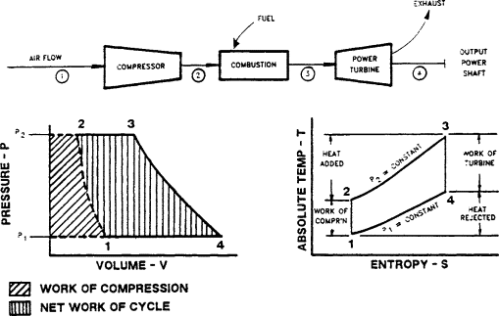

Fig 1.1.1 Working Flow Chart of Gas Turbine and Volume and Entropy Graphs of Brayton cycle

In this cycle, approximately 30% of the fuel consumed is available as power output. In addition, approximately 30% is used to drive the air compressors, 30% is contained in the hot exhaust gases, and 10% is lost to radiation and the lube oil system.

Simple cycle industrial [gas turbines](https://www.sciencedirect.com/topics/earth-and-planetary-sciences/gas-turbine) burn more fuel than comparable reciprocating machines. There are, however, several methods available to either reduce direct fuel consumption or use the available exhaust heat to reduce overall facility fuel requirements. Three common methods available are regeneration, waste heat recovery, and combined cycle operation. [1]

The modified [Brayton cycle](https://www.sciencedirect.com/topics/earth-and-planetary-sciences/brayton-cycle) is used for both [gas turbines](https://www.sciencedirect.com/topics/earth-and-planetary-sciences/gas-turbine) and jet engines. The turbine is designed to produce a usable [torque](https://www.sciencedirect.com/topics/earth-and-planetary-sciences/torque) at the output shaft, while the jet engine allows most of the hot gases to expand into the atmosphere, producing usable thrust. Emissions from both turbines and jets are similar, as are their control methods. The emissions are primarily unburned hydrocarbons, unburned carbon which results in the visible exhaust, and oxides of nitrogen. Control of the unburned hydrocarbons and the unburned carbon may be accomplished by redesigning the fuel [spray nozzles](https://www.sciencedirect.com/topics/earth-and-planetary-sciences/spray-nozzle) and reducing cooling air to the combustion chambers to permit more complete combustion. [2] Manmade propulsion devices have existed for many centuries, and natural devices have developed through evolution. Most modem engines and gas turbines have one common denominator: compressors and turbines or "turbo machines". There are two general types of jet propulsion air-breathing and non-air-breathing engines. Air-breathing engines use oxygen from the atmosphere in the combustion of fuel. They include the turbojet, turboprop, ramjet, and pulse-jet. The term jet is generally used only in reference to air-breathing engines. Non air-breathing engines carry an oxygen supply. They can be used both in the atmosphere and in outer space. They are commonly called rockets and are of two kinds liquid-propellant and solid-propellant. Non-air breathing engines include rocket motors, nuclear propulsion systems, and electric propulsion systems. Air-breathing engines may be further divided into two groups, based on the way in which they compress air for combustion. The turbojet and turboprop each have a compressor, usually turbine-driven, to take in air. They are called gas-turbine engines. The ramjet and the pulse-jet do not have compressors. The thrust of the turbojet and ramjet results from the action of a fluid jet leaving the engine; hence, the name jet engine is often applied to these engines. The turbofan, turboprop, and turbo shaft engines are adaptations of the turbojet to supply thrust or power through the use of fans, propellers, and shafts. The "heart" of a gas turbine type of engine is the gas generator. The compressor, combustor, and turbine are the major components of the gas generator which is common to the turbojet, turbofan, turboprop, and turbo shaft engines. The purpose of a gas generator is to supply high-temperature and high-pressure gas. [2]

## 1.2 Turbojet engines

The most widely used air-breathing engine is the turbojet. After the air is drawn into the engine through an inlet, its pressure is first increased by a component called a compressor. The air then enters the combustion chamber, where it is burned with fuel to increase its temperature. The hot, high-pressure gas then expands through a wheel-like device called a turbine, where it produces power. The turbine is connected to the compressor by a shaft, and the power output of the turbine drives the compressor. At the turbine outlet the hot-gas pressure is still above that of the surroundings, and the final expansion takes place through an exhaust nozzle where the speed of the exhaust gas is increased. It is the final high-velocity jet that produces the thrust to push the plane through the air. Although in concept a jet engine is much simpler than a reciprocating engine that turns a propeller, the actual design for efficient operation is complex, and large jet engines are extremely costly. [2]

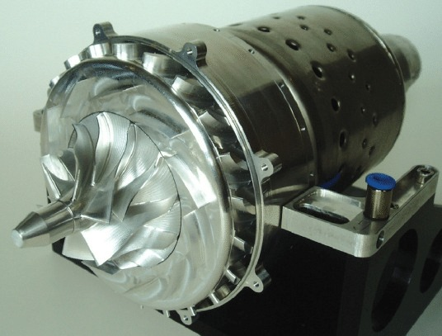

Fig 1.2.1 Real world prototype of Gas Turbine Engine

Today almost all airborne jet engines utilize axial-flow compressors. In these devices the air flows generally in one direction along the shaft that connects the compressor and the turbine; it moves through alternate rows of stationary and rotating sets of blades called stators and rotors respectively. The blades are arranged so that the entering air is slowed while passing through them and its pressure increased. Modern axial-flow compressors can increase the pressure 25-fold in about 16 "stages," each stage consisting of a set of rotor and stator blades. [2]

Centrifugal compressors, which were used in early aircraft jet engines, take air in at the center of an impeller, or vaned wheel, and compress it in a radial, or outward, direction.When the air in a turbojet engine leaves the compressor and enters the combustion chamber, it is mixed with a finely atomized kerosene-like fuel and burned. In theory, for best performance the burning temperature should be as high as can be achieved from the complete combustion of the fuel and the oxygen in the air. This would, however, make the turbine inlet temperature much too high for operation, and at present turbine inlet temperatures are limited to about 1,900 to 2,200 F (1,040 to 1,200 C). The temperature is controlled by burning only part of the compressor discharge air, while the rest is diverted past the burning section and mixed with the high-temperature gases farther along the combustion chamber. Combustion chambers can be composed of individual cans, or cylinders, arranged around the turbine shaft. Another approach is the use of an annular chamber in which a liner, or tubular sleeve, surrounds the shaft. Special alloys that are both strong and lightweight are required in turbine blades in order to withstand the high temperatures and stresses there. Among those under study are combinations of metals and ceramics called cermets. Turbine blades can be cooled by diverting some of the unburned compressor air and feeding it through internal passages to small holes at the front, or leading edge, of the turbine blades. This provides a film of cool air that protects the blade wall from the hot gases.

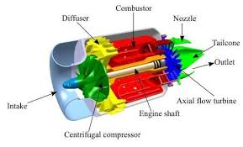

Fig 1.2.2 Sectional View of Gas Turbine Engine

A turbojet engine cannot be started directly from rest. An external starting motor starts the unit spinning. The fuel is then ignited by a heated spark plug. Once the engine is running, combustion can be maintained without a spark plug.

The useful output of the turbojet is its thrust, which is proportional to the mass flow rate of air through the engine and the change in velocity between the exit and the inlet. This makes it desirable to achieve a high velocity at the nozzle exit. Two performance characteristics are commonly used to describe turbojets: the specific thrust and the specific fuel consumption. The specific thrust produced (units of thrust per unit of engine gas flow per second) increases with the turbine inlet temperature. For this reason, engineers continuously seek higher turbine inlet temperatures by means of improved materials and better blade cooling. The specific fuel consumption (unit of thrust produced per unit of fuel burned per second), which is lowered as the engine efficiency is increased, improves with increasing pressure ratio. This requires more and more compressor stages. In an actual jet engine, there must be a trade-off between high pressures and high temperatures for best overall performance. Another important performance factor of the turbojet engine is the in-flight propulsion efficiency. In this case, the best performance is obtained if the jet exit (from the nozzle) velocity is about twice the flight velocity of the aircraft. As the thrust is increased by raising the turbine inlet temperatures, the turbine exit velocity also increases and the jet exit velocity becomes too high. In such a case, propulsion performance can be increased by adding bypass air.

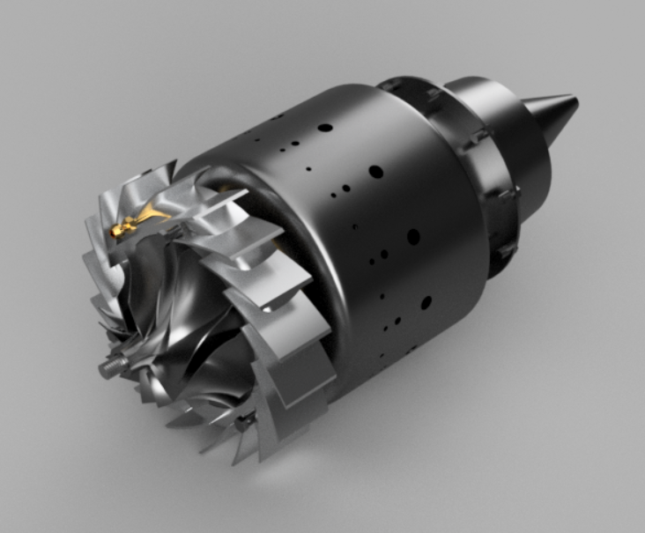

Fig 1.2.3 Rendered View of Gas Turbine Engine

## 1.3 Gas Turbine Cars

Gas turbine engines have numerous advantages over the piston engines that drive cost of our cars. Their high power to weight ratio makes them better suited for large jobs, and they operate well at high altitudes. They are not dependent on petroleum fuels, but can run on natural gas, kerosene, jet fuel and biofuels. They have their downsides as well. The fact that they run at high speeds and have high operating temperatures makes them more expensive to produce and maintain. They are inefficient when idling or accelerating. So, it makes sense that they are most often used to power large machinery such as commercial jets, helicopters, tanks and small power plants. [3]

The gas turbine engine used in cars are as similar to a [jet engine](https://en.wikipedia.org/wiki/Jet_engine), noting that it had only one [spark plug](https://en.wikipedia.org/wiki/Spark_plug) and about 80 percent fewer parts than a typical automotive piston engine. Due to their construction, the engines did not require [antifreeze](https://en.wikipedia.org/wiki/Antifreeze), a cooling system, a [radiator](https://en.wikipedia.org/wiki/Radiator_(engine_cooling)), [connecting rods](https://en.wikipedia.org/wiki/Connecting_rod), or [crankshafts](https://en.wikipedia.org/wiki/Crankshaft). The engine could operate on [diesel fuel](https://en.wikipedia.org/wiki/Diesel_fuel), [unleaded gasoline](https://en.wikipedia.org/wiki/Gasoline), [kerosene](https://en.wikipedia.org/wiki/Kerosene), and [JP-4 jet fuel](https://en.wikipedia.org/wiki/JP-4_(fuel)) and could burn a variety of unusual fuels ranging from [furnace oil and perfume to peanut and](https://en.wikipedia.org/wiki/Furnace_oil)  [soybean oils](https://en.wikipedia.org/wiki/Soybean_oil). Compared to conventional piston engines, turbine engines generally require less maintenance, last longer, and start more easily in cold condition. Gas turbine engines tend to be lighter and have better power to weight ratios than piston engines, as well as being able to use a variety of fuels. [3]

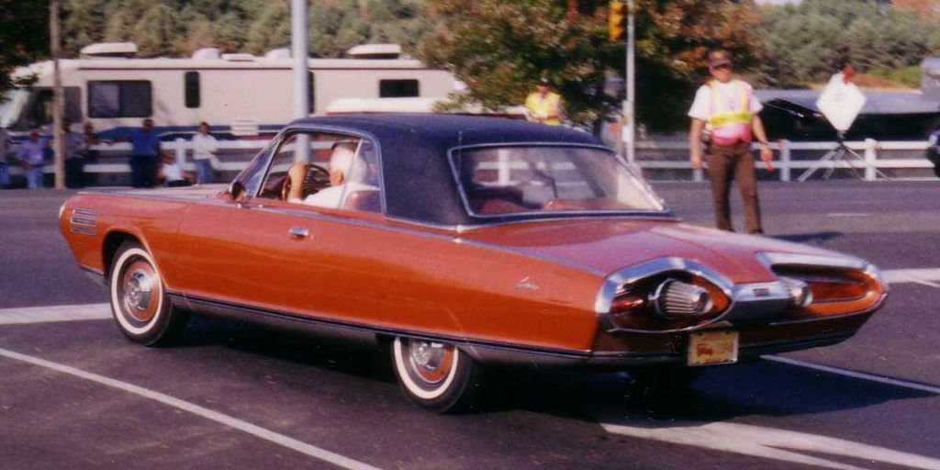

Fig 1.2.4 Photo of a Chrysler Turbine Car

## 1.4 Autodesk Fusion 360

Autodesk, Inc. is an American [multinational](https://en.wikipedia.org/wiki/Multinational_corporation) [software](https://en.wikipedia.org/wiki/Software) corporation that makes software services for the architecture, engineering, construction, manufacturing, media, education, and entertainment industries. The manufacturing industry uses Autodesk's [digital prototyping](https://en.wikipedia.org/wiki/Digital_prototyping) software—including [Autodesk Inventor](https://en.wikipedia.org/wiki/Autodesk_Inventor), Fusion 360, and the Autodesk Product Design Suite—to visualize, simulate, and analyze real-world performance using a digital model in the design process. It’s used to create **2D** and**3D drawings**—to conceptualize ideas, produce designs and even perform simulations. It was initially created for mechanical engineers, but has since branched out into other industries with discipline-specific enhancements—including AutoCAD Architecture, AutoCAD Civil 3D and AutoCAD Electrical. Autodesk Fusion 360 is a collaborative, cloud-enabled design platform that has all of the features mentioned above and more. It includes all the tools you need to go from design to fabrication, without having to leave the tool. [Fusion 360](https://www.scan2cad.com/cad/solidworks-vs-fusion-360/) is a product aimed at meeting the [cloud-based CAD](https://www.scan2cad.com/cad/will-cloud-impact-cad/) trend that has cropped up in the CAD sector in the past five years or so. It’s a **3D CAD**, **CAM** and **CAE** tool that allows users to complete an entire development process in a single cloud-based platform.

# Chapter 2

# MOTIVATION AND PROBLEM STATEMENT

The modern day commuting with transportation on margin has led to intensive growth in economy, but on the other hand has led to immense usage of fossil fuels like coal, petroleum, etc. The present-day transport system which uses reciprocating engines have advantages when it comes to cost, economy growth but on the darker side the exhaust gases, efficiency, etc comes into picture. Thus, an intensive search for an alternative low emission power plant, better efficiency and comparatively less polluting exhaust gases for passenger car has led to a re-evaluation of the gas turbine for this particular service. Considering these conditions, a change in the modern-day transport system with gas turbine engine as a replacement for the tenacious petroleum-based engines has motivated us to model a single stage gas turbine engine. This conceptual theory on modelling of a gas turbine engine can in later stages bring about actual development by implementing on real world basis.

When spoken of an automobile running on a gas turbine engine, there are lot of facts that are to be considered, with gas turbine engine in context, the question of efficiency, lubricating and ignition system and exhaust gas have lesser weightage when compared with the petroleum based reciprocating engines. A gas turbine engine can operate on variety of fuels which is one among the major drawbacks in reciprocating engines. Complications involved in design and number of parts involved is reduced by a factor of 80 percent in gas turbine engine. The engine life expectancy and maintenance have considerable advantages over reciprocating engines. Considering the effects on the environment and the economy gas turbine engines are predominantly advantageous.

# Chapter 3

# LITERATURE SURVEY

Based on the research, below are some of the literature reviewed to understand the various research activities carried out in the respective field.

[4] “Features of Computer Modelling of the Working Process of Small-scale Gas Turbine Engines”, was a research based on thermo gas dynamic model of small-scale gas turbine engine. The engine size is an important considerate when efficiency is assessed. The increased hydraulic losses and decreased turbo machinery efficiency due to the increasing of a boundary layer relative thickness and relative tip clearances is the key factor for working process of the micro engine. This article gives insights of the mathematical models that provide the corrected values of turbo machinery and combustion chamber efficiency ratios which may be used for conceptual designing of micro gas turbine engines.

[5] “Modelling and Simulation of Gas Turbine Engine Based on Object-oriented Approach”, was a study based on object-oriented design methods, in which emphasis is placed on modelling systems as collections of interacting objects, rather than processes, provide an improved approach to constructing models for gas turbine engine simulation. The model based on detailed analysis of the aerothermodynamics of engine components, properties and methods for each component class, the basic class library of the simulation system methods are of good expansibility and flexibility and can be applied to the gas turbine engine performance calculations and the user can easily complete the simulation model creation.

[6] “Numerical Study of the Effects of Main Parameters on Micro-combustion for Micro-gas Turbine Engine”, a study based on the development of micro turbine engine, but the many issue with the development was the of combustion in a compact space. The Computational Fluid Dynamics (CFD) numerical simulation on micro combustion chamber of hydrogen and air mixture was conducted to calculate the flow rate and temperature in different conditions. Thus, a new structure of micro turbine engine with annular combustion chamber whose material is high temperature resistant alloy including micro shaft, micro turbine and micro compressor was designed and fabricated.

[7] “A Physics-Based Modelling Approach for Performance Monitoring in Gas Turbine Engines”, was a physics research study on modelling approach for performance deterioration monitoring of gas turbine engines. Thus, a single stage GTE model was developed to simulate the working conditions by calculating selected expected performance parameters using typical operating data. The model was calibrated with the performance of a freshly built GTE, and then utilized to calculate the baseline values of the exhaust gas temperature and the power of the GTE. Two performance indicators (heat loss index and power deﬁcit index) were proposed for monitoring the GTE degradation process and thus could clearly reveal the short-term variation of the performance and can also display the gradual degradation of the GTE during the operating time.

[8] “Method for Identification of Gas Turbine Engine Starting Process”, a study for identification of the staring process of a nonlinear dynamic gas turbine engine, based on determining the dynamic characteristics and approximating the experimental data by cubic splines. By evaluating derivatives in a noisy data the comparison of derivative filter outputs with ideal derivatives shows that an error does not exceed 0.2%. The developed nonlinear dynamic gas turbine engine model is approved to implement in the software for hardware-in-the-loop test-beds and in the on-board software for automatic control systems of gas turbine.

[9] “The Design and Realization of Gas Turbine Engine Test Visualization”, a study to realize the test visualization process on a gas turbine engine. An object oriented thought is used to build a basic module ,a 3D module and 2D graph of dynamic data test of the engine in which show the data coming from the data processing module are in agreement with the gas turbine engine model classes and data processing computation class were programmed with VC++ language. Thus, the system shows that the gas turbine engine test visualizations is effective in making the gas turbine engine test data visualizing and is helpful to understand the performance of tested object to the engine designer

[10] “Closed-Cycle Micro Gas-Turbine System with Overexpansion Turbines and Heat Regeneration for Underwater Application”, a study on developing a natural offshore resource. This paper analyses the cycles of the closed gas turbine unit (CGTU) of various designs; for the baseline, the research uses a heat-regenerating CGTU, as it is more cost effective compared to simple-cycle CGTUs. A closed cycle heat regenerative micro gas turbine engine (CMGTE) use single loops, organic fuels, and air oxidation, which means they do not require complex onshore infrastructure, thus the heat-regenerating CMGTE with overexpansion turbines can be seen as a promising new development in the micro gas turbine engines for underwater machinery.

[11] “A Six-Wafer Combustion System for a Silicon Micro Gas Turbine Engine”, a research paper published on the development of a 6-wafer combustion system for a silicon micro gas turbine engine. Fabricated by deep reactive ion etching through a total thickness of 3800 micro meter, this structure serves as the first demonstration of the hot flow path of a multilevel micro engine and was tested under hot temperature conditions for several tens of hours, thereby demonstrating the viability of silicon-based combustion systems for micro heat engine applications.

[12] “Mathematical Modelling of In-turbine Isothermal Expansion in the Gas Turbine Engine”, was a research study on mathematical modelling of gas turbine engine with isothermal expansion in the turbine. Thermodynamic calculation of the gas-turbine engine with isothermal expansion in the turbine are developed and realized in a programmatic manner, hence proving the efficiency of isothermal expansion application as a way of thermodynamic cycle improvement of turbojet engine and turbofan engine with a low bypass ratio.

[13] “Modelling and Simulation of a Aero Turbojet Engine with GasTurb”, a study on micro turbojet JetCAT-P80, an aviation gas turbine on which thermodynamic parameters of the various sections and the engine performance parameters of the design conditions were tested and solved with the Matlab software, which could provide model reference for gas turbine long-term safe operation in the laboratory. The simulation results accurately reflect the steady state performance of gas turbine, and the error between the simulation result and the gas turbine actual operating parameters was within reasonable limits which verify the correctness and rationality of the model established.

[14] “Modelling and Simulation of Small Turbojet Engine Ground Starting Process”, was a research-based study on the characteristics of a small turbojet engine starting process by building models on different phases. The system starting models is established with voltage and throttle opening as inputs, output is speed. The fitting curves are compared with the real curves hence proving the correctness of the established models. An idea of reducing the peak starting current by changing the input voltage while ensuring the speed is put forward. The results of sectional modelling and the effectiveness of mixed modelling of data and physical models agree with the idea of rationality.

[15] “Situational modelling and control of a small turbojet engine MPM 20”, a research-based article on a system of digital measurement of a particular small turbojet engine - MPM 20. This system is one of the possible realizations of situational control of a small aircraft turbo-compressor engine, which can be also expanded to real sized turbojet engines and also with further expansions will lead into the areas of implementation of predictive and diagnostics algorithms into the proposed control system. Thus, the propose situational model and situational control algorithms for the engine with use of certain methods of artificial intelligence can be implied for new methods of control of large-scale systems.

[16] “Dynamic modelling of a small scale turbojet engine”, a study on experiment of a small-scale turbojet engine JetCat P200, in which dynamic responses and characteristics of the engine are tested and modelled by two parts: the linear dynamic system from the throttle command to the rotor speed and the nonlinear function relationship between the rotor speed and the engine output thrust. Thus, the developed model describes the turbojet engine's input or output response with only two parameters, that which is simple and convenient for us to understand the input and output characteristics and make appropriate usage.

[17] “Development and Improvement of Compressor Performance Prognostics for US Navy Gas Turbine Engines”, a study based on the testing of an engine to collect data to improve a previously developed compressor health prognostics algorithm. During Phase I of this testing, fouling was accomplished by injecting salt into the gas turbine inlet air stream and causes a clear increase in inlet static pressure which is due to the mass flow restriction through the compressor. Phase II of this testing will consist of fouling the middle and back regions of the compressor occurs from a combination of ingested salt and oil seal leakage

# Chapter 4

# LITERATURE GAP

1. A lot of research work on modelling aspects of a gas turbine engine and it’s specifications are yet to be done for developing a Gas Turbine Engine for Automotive applications.

2. Manufacturability and economic usage for real world applications are yet to be considered in picture.

3. Engine loading (warm up and start up procedures) and heat suppressing problems are yet to be dealt with.

4. The concern over emissions control and miniaturization requires a significant amount of research work.

.

# Chapter 5

# OBJECTIVES

The objectives of current study have been enumerated below:

1. Identify the suitable specifications for modelling of an automobile gas turbine engine.
2. Modelling of a gas turbine engine for an automobile.
3. Creating a working animation of the engine.

# 

# Chapter 6

# METHOD AND METHODOLOGY

The project consists of three important phases, one is to identify the suitable specification for the modelling of an automobile gas turbine engine, two, creating a design model of the engine and three, to show the working animation of the engine using suitable design software.

Modifying necessary components

Rendering the model

Identify engine specification

Checking for compatibility

Creating a 2D sketch

Converting into a 3D model

Assembling the model

Creating a working animation.

Fig 6.1 Flow Chart of the Methodology

1. Identify engine specifications.

Suitable design specifications for modelling an engine is obtained using various referential sources.

1. Checking for compatibility.

The obtained design specifications are checked for component compatibility and the next step is creating a basic sketch of the model.

1. Creating a 2D sketch.

A two-dimensional sketch of each component is created using a design software using the obtained design specifications.

1. Converting into a 3-D model.

Extrusion of the component is done once the sketch of is compete in order to obtain a 3-Dimensional design framework.

1. Modifying necessary components.

Once the 3-D model of the component is complete, miscellaneous operations such as fileting, chamfering, combining, performance split body function, split phase, drafting, press pull, move/copy, align, etc are performed on different components.

1. Assembling the model.

The gas turbine engine model can be easily established in the system by dragging the components and arranging them in a logical order consistent with the physical model. Material and property selection for each component is done.

1. Rendering the model.

Once the material selection is completed, rendering of the model is done which suits the conceptual real-world prototype.

1. Creating a working animation.

A complete model of the gas turbine engine is created and working animation of the engine is developed to learn about each part function and the complete working of the engine.

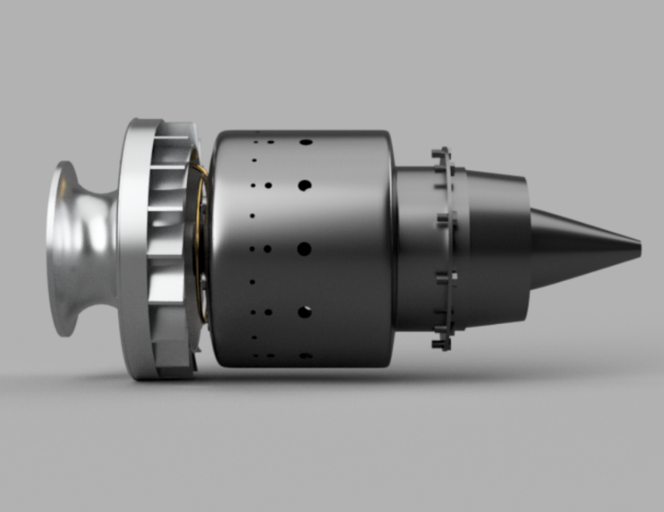

Fig 6.2 Final Model of Gas Turbine Engine

# Chapter 7

# MODELLING AND ANIMATION

Based on the acquired specifications modelling procedures are undertaken for each component using a design software, Fusion 360. A model animation is developed in order to learn about the function of the model, part wise and the overall working of the engine.

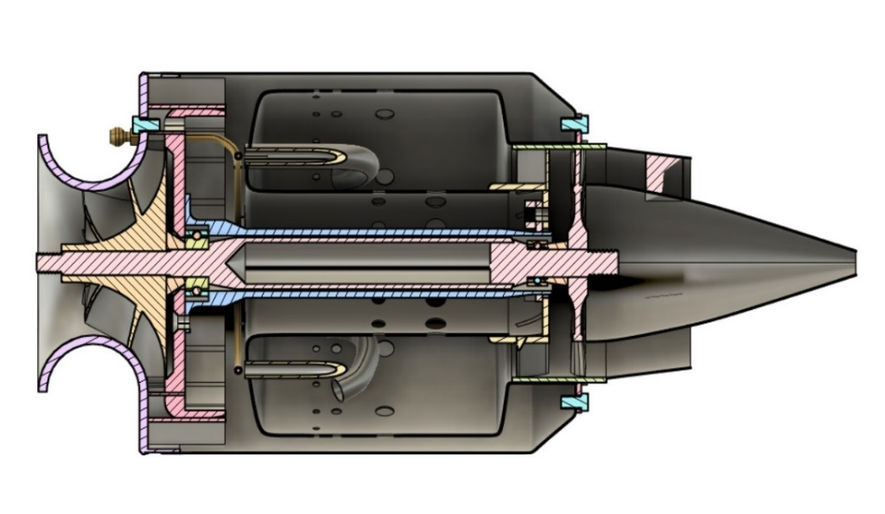

Fig 7.0.1 Rendered Cut Section View of Gas Turbine Engine

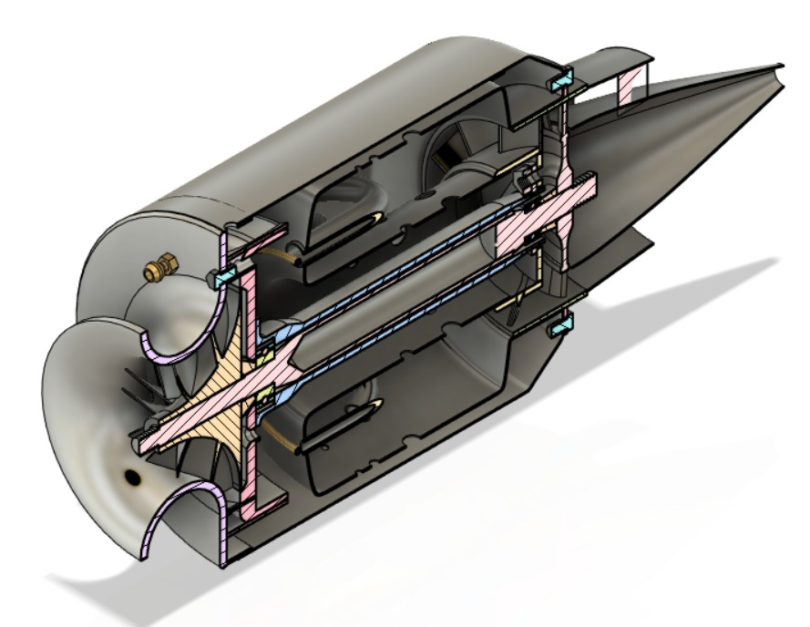

Fig 7.0.2 Rendered Isometric Cut Section View of Gas Turbine Engine

**Main Components of a Jet engine**

The main components of a Jet Engine are as follows

1. Combustion Chamber
2. Main Shaft
3. Compressor Diffuser
4. Compressor
5. NGV Holder
6. Diffuser Cone
7. Fuel Injector Ring
8. Shaft House
9. Turbine
10. Inlet Space

7.1 Combustion chamber

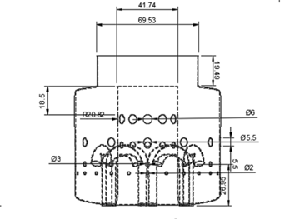

Fig 7.1.1 Right View of Combustion chamber

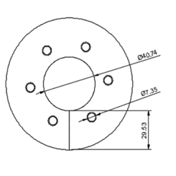

Fig 7.1.3 Back View of Combustion chamber

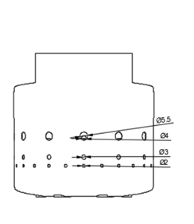

Fig 7.1.2 Top View of Combustion chamber

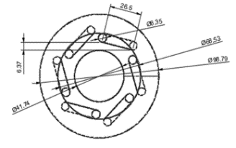

Fig 7.1.4 Front View of Combustion chamber

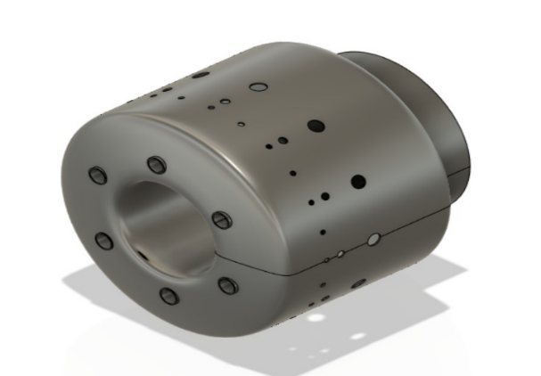

Fig 7.1.5 Isometric View of Combustion chamber

**Description**

1. Fuel starts to burn continuously once it is ignited initially during engine start.

2. Combustors usually have structures to give a protected combustion zone called a flame holder. They have various types like the can, annular, and can-annular type.

3. We must make sure that we keep the flame burning in a moderately fast-moving airstream, at all throttle conditions, as efficiently as possible. Since the turbine cannot withstand stoichiometric temperatures, some of the compressor air is used to quench the exit temperature of the combustor to an acceptable level. Air used for combustion is considered to be primary airflow, while excess air used for cooling is called secondary airflow.

4. The material used here is Steel alloy.

5. The 2D drawing of the model is shown.

**COMBUSTION CHAMBER DIMENSIONAL DATA:**

|  |  |  |
| --- | --- | --- |
| Sl.No | DESCRIPTION | DIMENSIONS (in mm) |
| 1) | TUBE DIAMETER | 40 |
| 2) | INJECTION TUBE DIAMETER | 7.5 |
| 3) | OUTER DIAMETER | 100 |
| 4) | PRIMARY HOLES DIAMETER | 2 |
| 5) | SECONDARY HOLES DIAMETER | 3 |
| 6) | TERTIARY HOLE DIAMETER | 5.5 |
| 7) | EXIT TUBE DIAMETER | 70 |

Table 7.1 Dimensional data of Combustion Chamber

## 7.2 Main Shaft

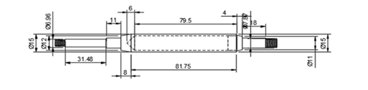

Fig 7.2.1 Right View of Main Shaft

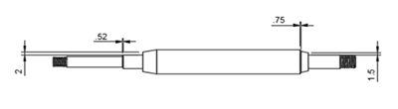

Fig 7.2.2 Left View of Main Shaft

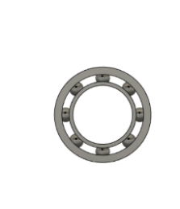

Fig 7.2.3 Front View of Bearing

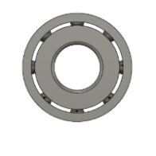

Fig 7.2.4 Front View of Bearing

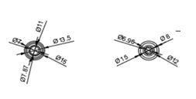

Fig 7.2.5 Isometric View of Bearing

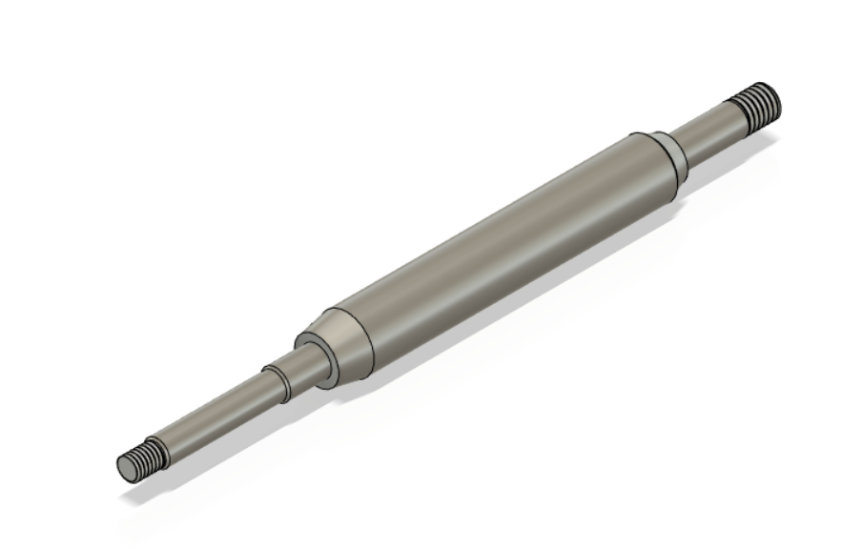

Fig 7.2.6 Isometric View of Main Shaft

**Description**

1. This is the main shaft which is used to connect the compressor to the turbine.
2. It runs throughout the length of the engine.
3. Depending on the number of compressors and turbines, there can be many concentric shafts running simultaneously and operates with same or different speeds.
4. The air which is used to cool the heated turbines could also flow through these shafts.
5. The material used is Aluminum.
6. The 2D drawing of the model is shown.

**MAIN SHAFT DIMENSIONAL DATA:**

|  |  |  |
| --- | --- | --- |
| Sl.No | DESCRIPTION | DIMENSIONS (in mm) |
| 1) | OUTER DIAMETER | 15 |
| 2) | INNER DIAMETER | 3.5 |
| 3) | SECONDARY DIAMETER | 12 |
| 4) | TERTIARY DIAMETER | 8 |
| 5) | THREADING (SQUARE THREAD) | 7.5 |
| 6) | LENGTH | 87 |
| 7) | FILLET RADIUS | 2 |

Table 7.2 Dimensional data of Main Shaft

## 7.3 Compressor

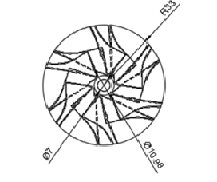

Fig 7.3.1 Front View of Compressor

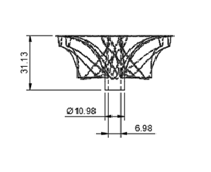 Fig 7.3.3 Top View of Compressor

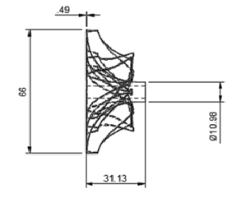

Fig 7.3.2 Left View of Compressor

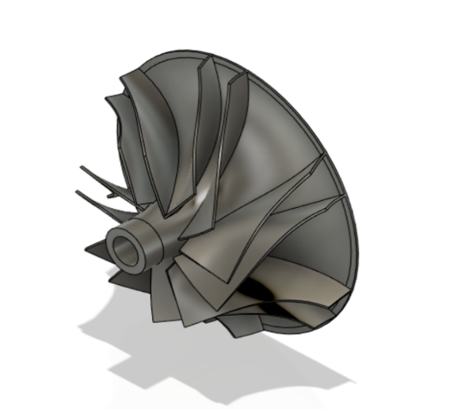

Fig 7.3.4 Isometric View of Compressor

**Description**

1. This component has various working stages. Each stage consists of rotors and stators. As the air moves through the compressor, its pressure and temperature increase.
2. Axial compressors mostly depend on the moving blades that have aero foil sections i.e. very similar to an airplane wing.
3. In certain working conditions the blades might stall/stop and if this happens, the airflow around the compressor can change its direction violently.
4. Its main function is to pressurize the gases. The engine sucks in the air at the fan and compression occurs. This produces a very high velocity air which is harmful and is controlled by the diffuser.
5. This Process is usually done in stages, if done in a single stage the pressure gradient becomes very high (Very heavy load on the blades) and the failure of compressor occurs.
6. The material used is Steel.
7. The 2D drawing of the model is shown.

**COMPRESSOR DIMENSIONAL DATA:**

|  |  |  |
| --- | --- | --- |
| Sl.No | DESCRIPTION | DIMENSIONS (in mm) |
| 1) | OUTER DIAMETER | 66 |
| 2) | INNER DIAMETER | 10 |
| 3) | HOLE DIAMETER | 7 |
| 4) | BLADE ANGLE | 6.51 (DEGREES) |
| 5) | BLADE THICKNESS | 0.5 |

Table 7.3 Dimensional data of Compressor

## 7.4 Compressor Diffuser

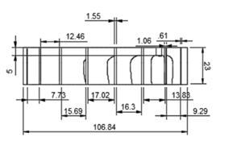

Fig 7.4.1 Top View of Compressor Diffuser

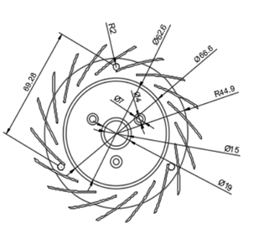

Fig 7.4.2 Front View of Compressor Diffuser

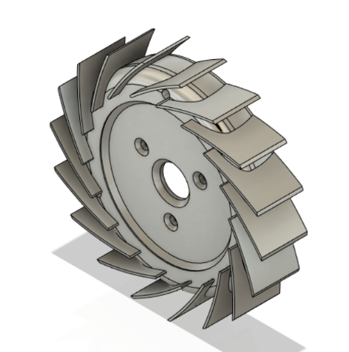

Fig 7.4.3 Isometric View of Compressor Diffuser

**Description**

1. The diffuser is a divergent section of the engine which comes after the compressor and before the combustion section.
2. Its function in the jet engine design is to reduce the high-velocity air, which is given out by the compressor reaching higher pressure at slow velocities.
3. This function prepares the air to enter the region of the flame burning area of the combustion section at lower velocity such that the flames produced during the entire combustion process can burn continuously and efficiently.
4. The compressor diffuser is a very important component of the engine because if the air passed through the combustion area at a higher velocity, it could extinguish the flame and disrupt the entire process.
5. The material used is Steel RQC100
6. The 2D model of the model is shown.

**COMPRESSOR DIFFUSER DIMESIONAL DATA:**

|  |  |  |
| --- | --- | --- |
| Sl.No | DESCRIPTION | DIMENSIONS (in mm) |
| 1) | OUTER PLATE DIAMETER | 90 |
| 2) | INNER PLATE DIAMETER | 62.5 |
| 3) | HOLE DIAMETER | 19 |
| 4) | TRIANGULAR SCREW HOLE DIAMETER | 4 |
| 5) | OUTER SCREW HOLE RADIUS | 2 |
| 6) | BLADE THICKNESS | 0.85 |
| 7) | BLADE HEIGHT | 30 |

Table 7.4 Dimensional data of Compressor Diffuser

## 7.5 NGV (Nozzle Guide Vanes)

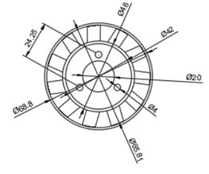

Fig 7.5.1 Front View of NGV

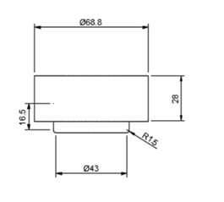

Fig 7.5.3 Rotated Right View of NGV

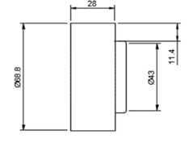

Fig 7.5.2 Right View of NGV

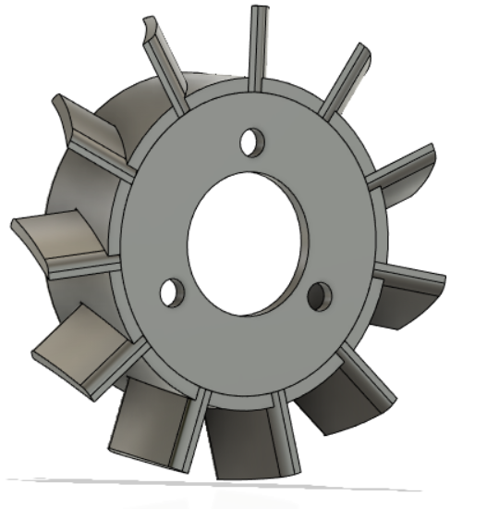

Fig 7.5.4 Isometric View of NGV

**Description**

1. NGV or Nozzle Guide Vanes are stator blades of the engine. Since very high pressure and velocity air strike these vanes, a strong holder is necessary so that the vanes don’t fail.
2. The vanes are convex in shape like aero foils and these are used to guide the airflow into the turbine.
3. After the combustion process the exhausts gases exits the combustion chamber passes through the vanes and due to their special shape, it accelerates.
4. These vanes also convert pressure energy into kinetic energy and give the gases a spin or a swirl into the path of the rotating blades of the turbine.
5. The NGV and its holder is very important as sometimes the Reynolds number of gases exceeds the limit and hence are used to control them otherwise the engine fails.
6. The material used is Steel Alloy.
7. The 2D drawing of the model is shown.

**NGV- SYSTEM DIMENSIONAL DATA:**

|  |  |  |
| --- | --- | --- |
| Sl.No | DESCRIPTION | DIMENSIONS (in mm) |
| 1) | PLATE DIAMETER | 46 |
| 2) | HOLE DIAMETER | 20 |
| 3) | SCREW HOLE DIAMTER | 4 |
| 4) | BLADE HEIGHT | 11 |
| 5) | BLADE THICKNESS | 1 |
| 6) | WIDTH | 18 |

Table 7.5 Dimensional data of Nozzle Guide Vane

## 7.6 Diffuser Cone

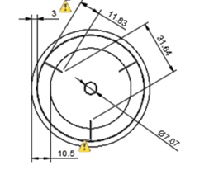

Fig 7.6.1 Back View of Diffuser Cone

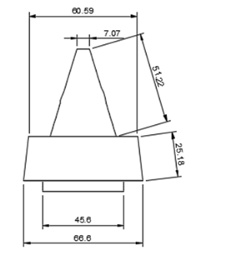

Fig 7.6.3 Rotated Right View Diffuser Cone

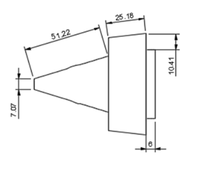Fig 7.6.2 Right View of Diffuser Cone

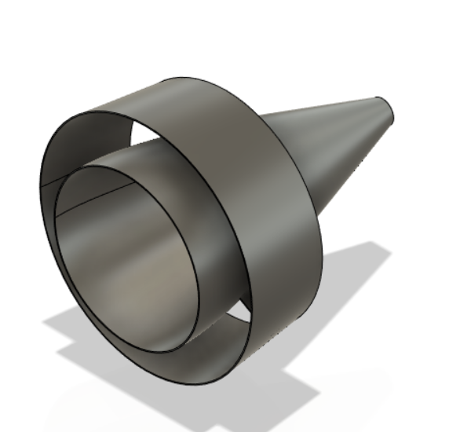

Fig 7.6.4 Front View of Diffuser Cone

**Description**

1. The diffuser cone is shaped such that the shock wave that forms on its apex is directed to the tip of the intake, this allows the intake to operate properly.
2. As speed increases, the shock wave becomes increasingly more oblique i.e. slanting.
3. Diffuser cones are designed to move the air axially to the exhaust and control the duct external throat area.
4. The material used is steel alloy
5. The 2D drawing of the model is shown.

**DIFFUSER CONE DIMENSIONAL DATA:**

|  |  |  |
| --- | --- | --- |
| Sl.No | DESCRIPTION | DIMENSIONS (in mm) |
| 1) | CONE HEIGHT | 50 |
| 2) | CONE LAREGER END DIAMETER | 20 |
| 3) | CONE SMALLER END DIAMETER | 7 |
| 4) | No. of FLANGES | 3 |
| 5) | FLANGE THICKNESS | 0.3 |
| 6) | FLANGE LENGTH | 10 |

Table 7.6 Dimensional data of Diffuser Cone

## 7.7 Fuel Injector Ring

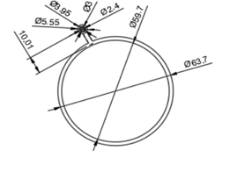

Fig 7.7.1 Front View of Fuel Injector Ring

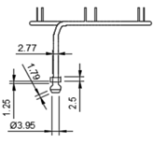

Fig 7.7.3 Top View of Fuel Injector Ring

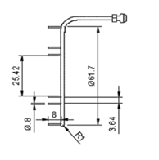

Fig 7.7.2 Left View of Fuel Injector Ring

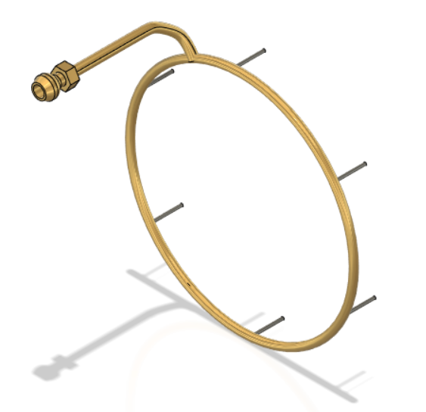

Fig 7.7.4 Isometric View of Fuel Injector Ring

**Description**

1. A simple but efficient fuel injector has a constructive design which includes a fuel pump with constant pressure chamber within control scheme for the engine’s speed or exhaust gases temperature.
2. This type of fuel injection controller assures the required fuel flow rate adjusting the dosage valve effective area, keeping fuel pressure constant.
3. In general, the fuel injector is responsible for introducing fuel to the combustion zone and, along with the swirler is responsible for mixing the fuel and air.
4. There are four primary types of fuel injectors, pressure-atomizing, air blast, vaporizing, and pre-vaporizing injectors.
5. The material used is Brass
6. The 2D drawing of the model is shown

**FUEL INJECTOR RING DIMENSIONAL DATA:**

|  |  |  |
| --- | --- | --- |
| Sl.No | DESCRIPTION | DIMENSIONS (in mm) |
| 1) | No. of INJECTION TUBES | 6 |
| 2) | RING OUTER DIAMETER | 63.7 |
| 3) | RING INNER DIAMETER | 59.7 |
| 4) | INLET TUBE DIAMETER | 4 |
| 5) | INJECTOR TUBE OUTER DIAMETER | 0.8 |
| 6) | INJECTOR TUBE INNER DIAMETER | 0.5 |

Table 7.7 Dimensional data of Fuel Injector Ring

## 7.8 Shaft House

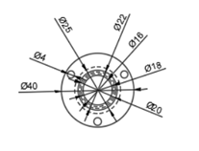

Fig 7.8.1 Front View of Shaft House

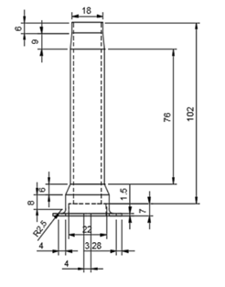

Fig 7.8.2 Top View of Shaft House

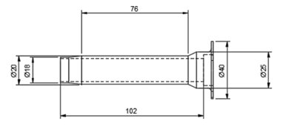

Fig 7.8.3 Rotated Top View of Shaft House

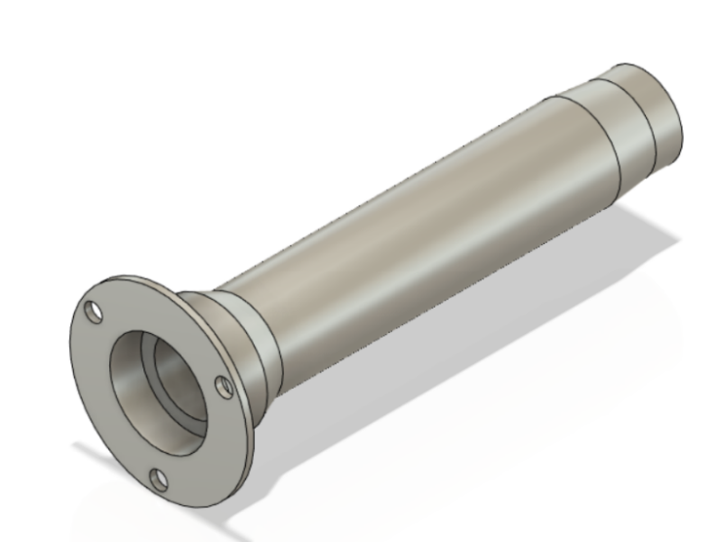

Fig 7.8.4 Isometric View of Shaft House

**Description**

1. The shaft house is the casing for the main shaft. It acts as a protective layer to the main shaft.
2. Its main purpose is to transfer approximately 25% of the energy from the turbine to the compressor.
3. The material used here is Aluminum.
4. The 2D drawing of the model is shown

**SHAFT HOUSE DIMENSIONAL DIAMETER:**

|  |  |  |
| --- | --- | --- |
| Sl.No | DESCRIPTION | DIMENSIONS (in mm) |
| 1) | OUTER DIAMETER | 40 |
| 2) | INNER DIAMETER | 22 |
| 3) | HOLE DIAMETER | 16 |
| 4) | SCREW HOLE DIAMETER | 4 |
| 5) | LENGTH | 110 |
| 6) | FILLET RADIUS | 3 |
| 7) | THICKNESS | 3 |

Table 7.8 Dimensional data of Shaft House

## 7.9 Turbine

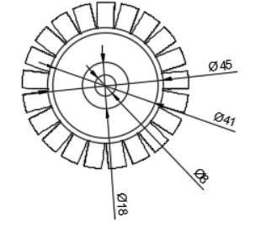

Fig 7.9.1 Front View of Turbine

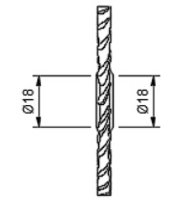

Fig 7.9.2 Top View of Turbine

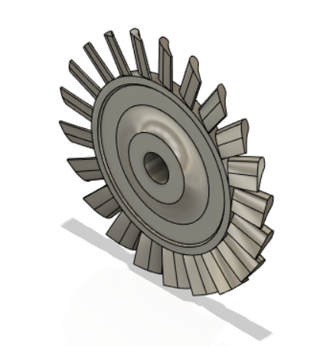

Fig 7.9.3 Isometric View of Turbine

**Description**

1. The high-energy air from the combustor flows into the turbine, causing the turbine blades to rotate. The turbines are linked by a shaft rotating the blades of the compressor and the intake fan at the front.

2. This rotation absorbs some energy from the high-energy flow which drives the fan and the compressor. The gases produced in the combustion chamber move through the turbine and spin its blades.

3. The turbines of the jet engine rotates about a number of times and are fixed on shafts which have several sets of ball-bearing between them.

4. Turbine blades are made up of titanium to sustain the high heat produced & the turbine wheel is made up of steel alloy.

5. The 2D drawing of the model is shown

**TURBINE DIMENSIONAL DATA:**

|  |  |  |
| --- | --- | --- |
| Sl.No | DESCRIPTION | DIMENSIONS (in mm) |
| 1) | OUTER PLATE DIAMETER | 45 |
| 2) | INNER PLATE DIAMETER | 8 |
| 3) | HOLE DIAMETER | 8 |
| 4) | OUTER DIAMETER | 65 |
| 5) | WIDTH | 6 |
| 6) | BLADE HEIGHT | 10 |
| 7) | BLADE END WIDTH | 0.44 |
| 8) | BLADE CURVE WIDTH | 2 |
| 9) | FILLET RADIUS | 1 |

Table 7.9 Dimensional data of Turbine

## 7.10 Inlet Space

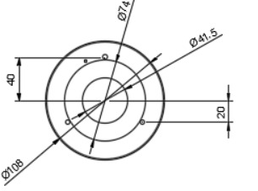

Fig 7.10.1 Front View of Inlet Space

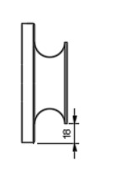

Fig 7.10.2 Bottom View of Inlet Space

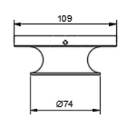

Fig 7.10.3 Right View of Inlet Space

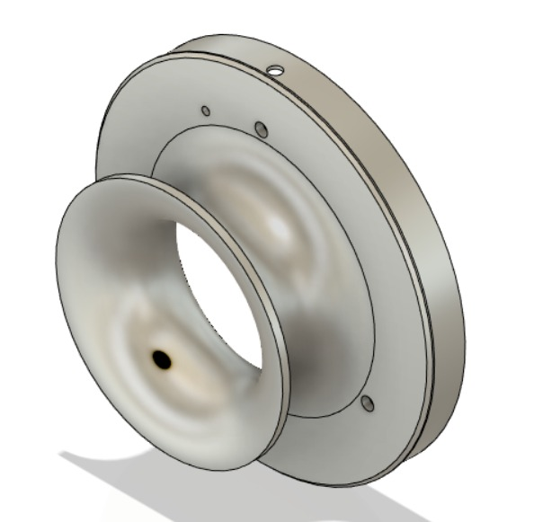

Fig 7.10.4 Isometric View of Inlet Space

**Description**

1. Inlet Space is a passage for air connecting the compressor diffuser

2. It acts as a casing for the Compressor diffuser and the Compressor.

3. It is made up of Aluminum

4. It is a stationary part at it lies at the cold region of the Engine.

5. The 2D drawing of the model is shown

**INLET SPACE DIMENSIONAL DATA:**

|  |  |  |
| --- | --- | --- |
| Sl.No | DESCRIPTION | DIMENSIONS (in mm) |
| 1) | OUTER DIAMETER | 108 |
| 2) | HOLE DIAMETER | 41.5 |
| 3) | INLET FILLET RADIUS | 7 |
| 4) | FILLET RADIUS | 2 |

Table 7.10 Dimensional data of Inlet Space

# Chapter 8

# RESULTS AND DISCUSSION

Based on the specifications obtained a CAD model of a gas turbine engine for an automobile is developed using the software Fusion 360. A single stage compressor with radial and axial flow, a single stage turbine, annular type combustor was modelled into a complete engine using the design software. A model animation is developed in order to learn about the function of the model part wise and the overall working of the engine. Use of this model during the conceptual designing stage provides more adequate results of working process parameters optimization and design development.

## 

# 

# Chapter 9

# CONCLUSION

This study is based on the development of a model of a gas turbine engine for an automobile using suitable design software. An engine comprising of a single stage compressor, a single stage turbine, an annular type combustor is modelled using a design software. Design software, Fusion 360 is the key which led to a conceptual model development of the engine. The gas turbine engine model can be easily established in the system by dragging the components and arranging them in a logical order consistent with the physical model. Working of the model is understood by creating an animation which gives detailed information on function of each component and the engine as a whole. Thus a brief understanding on conceptual modelling procedures of a gas turbine engine for automotive applications is conveyed.

# FUTURE WORK

The creation of such computer model can be the basis for development of gas turbines and their digital control systems in the future. Detailed modelling in later stages, taking into account every aspect of the engine can bring about actual development in this field by implementing in real world scenarios when applied in daily usage. A hybrid system can be used as an alternative for starting problems in a gas turbine engine. In this case electric motors are used to power the shaft which in turn rotates the compressor causing air suction and thus aiding the engine start up process. Hence a lot of research work on modelling a gas turbine engine is to be done in order to have it made applicable for real world application

# REFERENCES

[1]. E. S. Wright, L. E. Greenwald and R. R. Titus (1972), “Automotive Gas TurbineOptimum Configuration Study”, United Aircrafts Research Laboratories.

[2] D. Klein and C. Abeykoon, "Modelling of a turbojet gas turbine engine," 2015 Internet Technologies and Applications (ITA), Wrexham, 2015, pp. 200-206, doi: 10.1109/ITechA.2015.7317395.

[3]. Collman, John & Amann, Charles & Matthews, Charles & Stettler, Richard & Verkamp, Francis. (1975). The GT-225-An Engine for Passenger-Car Gas-Turbine Research. 10.4271/750167.

[4]. V. S. Kuz'michev, A. Y. Tkachenko, Y. A. Ostapyuk, I. N. Krupenich and E. P. Filinov, "Features of computer Modelling of the working process of small-scale gas turbine engines," 2017 International Conference on Mechanical, System and Control Engineering (ICMSC), St. Petersburg, 2017, pp. 136-140, doi: 10.1109/ICMSC.2017.7959458.

[5].X. Zhang, "Modelling and simulation of gas turbine engine based on object-oriented approach," 2017 17th International Conference on Control, Automation and Systems (ICCAS), Jeju, 2017, pp. 551-555, doi: 10.23919/ICCAS.2017.8204295.

[6]. Z. Zeng, Z. Wang and G. Song, "Numerical Study of the Effects of Main Parameters on Micro-combustion for Micro-gas Turbine Engine," 2010 Asia-Pacific Power and Energy Engineering Conference, Chengdu, 2010, pp. 1-4, doi: 10.1109/APPEEC.2010.5449388.

[7]. H. Hanachi, J. Liu, A. Banerjee, Y. Chen and A. Koul, "A Physics-Based Modelling Approach for Performance Monitoring in Gas Turbine Engines," in IEEE Transactions on Reliability, vol. 64, no. 1, pp. 197-205, March 2015, doi: 10.1109/TR.2014.2368872.

[8]. O. D. Lyantsev, A. I. Abdulnagimov and A. V. Kazantsev, "Method for Identification of Gas Turbine Engine Starting Process," 2018 International Russian Automation Conference (RusAutoCon), Sochi, 2018, pp. 1-5, doi: 10.1109/RUSAUTOCON.2018.8501652.

[9]. Xunbo Li, Dewu Liu, Tianyou Hu, Yan Shen and Taiwen Yuan, "The design and realization of gas turbine engine test visualization," 2008 IEEE International Conference on Mechatronics and Automation, Takamatsu, 2008, pp. 1111-1115, doi: 10.1109/ICMA.2008.4798914.

[10]. V. T. Matviienko, A. V. Dologlonyan and A. N. Grekov, "Closed-Cycle Micro Gas-Turbine System with Overexpansion Turbines and Heat Regeneration for Underwater Application," 2019 International Multi-Conference on Industrial Engineering and Modern Technologies (FarEastCon), Vladivostok, Russia, 2019, pp. 1-4, doi: 10.1109/FarEastCon.2019.8933910.

[11]. A. Mehra, Xin Zhang, A. A. Ayon, I. A. Waitz, M. A. Schmidt and C. M. Spadaccini, "A six-wafer combustion system for a silicon micro gas turbine engine," in Journal of Microelectromechanical Systems, vol. 9, no. 4, pp. 517-527, Dec. 2000, doi: 10.1109/84.896774.

[12]. I. Goryunov and M. Muraeva, "Mathematical Modelling of In-turbine Isothermal Expansion in the Gas Turbine Engine," 2018 International Russian Automation Conference (RusAutoCon), Sochi, 2018, pp. 1-5, doi: 10.1109/RUSAUTOCON.2018.8501837.

[13]. J. Gao and Y. Huang, "Modelling and Simulation of an Aero Turbojet Engine with GasTurb", 2011 International Conference on Intelligence Science and Information Engineering, Wuhan, 2011, pp. 295-298, doi: 10.1109/ISIE.2011.149.

[14]. L. Baoan and Z. Fan, "Modelling and Simulation of Small Turbojet Engine Ground Starting Process," 2012 Second International Conference on Instrumentation, Measurement, Computer, Communication and Control, Harbin, 2012, pp. 28-32, doi: 10.1109/IMCCC.2012.14.

[15]. R. Andoga, L. Fozo and L. Madarasz, "Situational Modelling and control of a small turbojet engine MPM 20," 2006 IEEE International Conference on Computational Cybernetics, Budapest, 2006, pp. 1-5, doi: 10.1109/ICCCYB.2006.305727.

[16]. Y. Jiali and Z. Jihong, "Dynamic modelling of a small scale turbojet engine," 2015 European Control Conference (ECC), Linz, 2015, pp. 2750-2755, doi: 10.1109/ECC.2015.7330954.

[17]. J. Scharschan and D. Caguiat, "Development and improvement of compressor performance prognostics for US Navy gas turbine engines," 2005 IEEE Aerospace Conference, Big Sky, MT, 2005, pp. 3472-3478, doi: 10.1109/AERO.2005.1559650.